1. **Determine the sales and quantity of products in each state?**

**Query with output:**

1. **Identify the cities and states with the highest sales volumes**

**Query with output:**

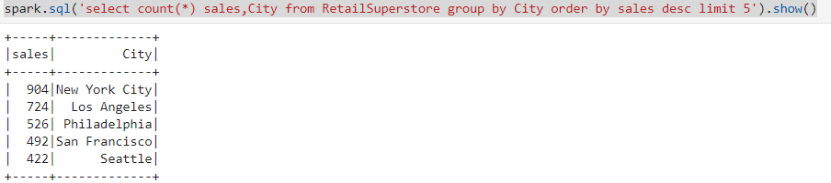

1. **Determine the sum of profits vs sum of sales across all the states.**

**Query with output:**

1. **Find the average profit from sales across all the segments and regions.**

**Query with output:**

1. **Categorize all the states based on profit or loss.**

**Query with output:**

1. **Identify the top-selling products and their sales trends over time.**

**Query with output:**

1. **Identify the customers with the highest purchasing frequency and determine their preferred sub-category and categories.**

**Query with output:**

1. **Find number of orders placed based on shipment mode ?**

**Query with output:**

